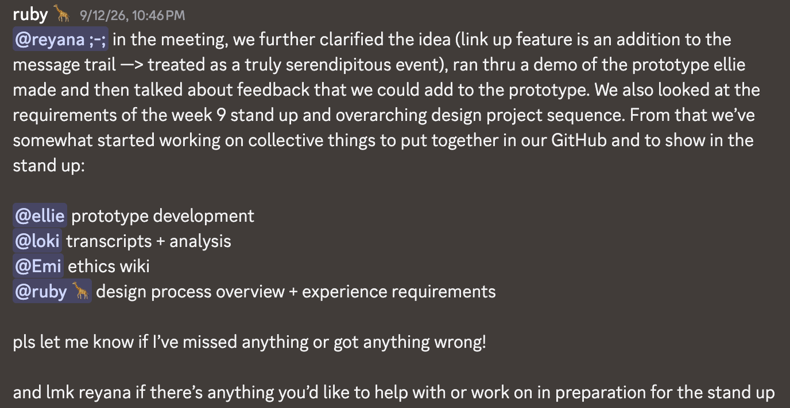
Reyana did not reply until Week 8 14/9 and therefore had not been tasked with anything.

